Task 1:

#include<iostream>

using namespace std;

int sum(int n)

{

if (n == 0)

{

return n;//when n reches 0 it prints the sum

}

else

return n+sum(n-1);//sum 5 and 5-1=4;decreses num and sum the value

}

int main()

{

int num=0;

cout << "enter num\n";

cin >> num;

cout<<sum(num);

}

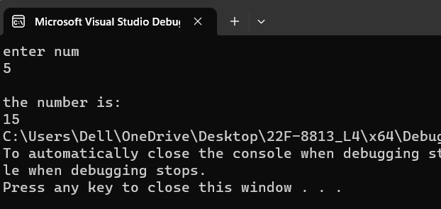

Task 2:

#include<iostream>

using namespace std;

int fib(int n,int s1, int s2)

{

int temp = 0;//temporary variable

if (n <0)

{

return false;//not run for num less than 0 or -ve values

}

if (n == 0)

{

return 1;

}

else

temp = s1 + s2;

cout << s1 << " ";

s1 = s2;//swaps the positions

s2 = temp;

return fib(n - 1, s1, s2);//decreses the num value

}

int main()

{

int num,s1=0,s2=1;//s1=start position and s2 = 2nd position

cout << "enter num\n";

cin >> num;

fib(num,s1,s2);

}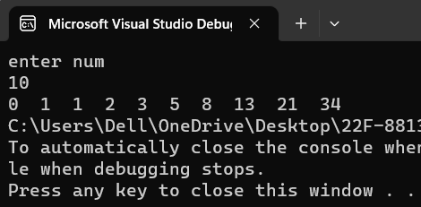

Task4:

#include <iostream>

using namespace std;

struct Car

{

char carName[20];

char carModel[20];

int yearModel;

double cost;

};

struct Car2

{

char carName[20];

char carModel[20];

int yearModel;

double cost;

};

int main()

{//input all the cars things;

Car c1;

cout << "enter car1 name: ";

cin>>c1.carName;

cout << "enter car1 model: ";

cin >> c1.carModel;

cout << "enter car1 modalyear: ";

cin >> c1.yearModel;

cout << "enter car1 cost: ";

cin >> c1.cost;

cout << endl << endl;

Car c2;

cout << "enter car2 name: ";

cin >> c2.carName;

cout << "enter car2 model: ";

cin >> c2.carModel;

cout << "enter car2 modalyear: ";

cin >> c2.yearModel;

cout << "enter car2 cost: ";

cin >> c2.cost;

cout << endl << endl;

//compare the cars cost and prints the name

if (c1.cost > c2.cost)

{

cout << " "<<c1.carName << " is expensive";

}

else if (c2.cost > c1.cost)

{

cout << " "<<c2.carName << " is expensive";

}

else

{

cout << "they are equal\n";

}

}

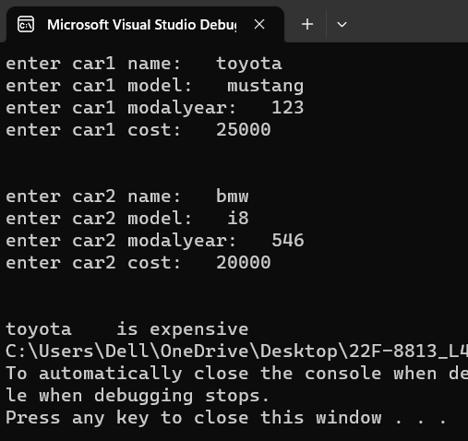

Task 5:

#include<iostream>

using namespace std;

struct distanc //distance is reserved in memory so we wrote distanc

{

int ft;

double inch;

};

int main()

{

int temp = 0;

float tempf = 0.0;

distanc d1;

cout << "enter feets of room 1: ";

cin >> d1.ft;

while (d1.ft<0)

{

cout << "enter feets of room 1: ";

cin >> d1.ft;

}

cout << "enter inches of room 1: ";

cin >> d1.inch;

while (d1.inch < 0)

{

cout << "enter inches of room 1: ";

cin >> d1.inch;

}

distanc d2;

d2.ft = 10;

d2.inch = 5.25;

distanc d3;

d3.ft = d1.ft + d2.ft;

d3.inch = d1.inch + d2.inch;

cout << "\nd1 feets are : " << d1.ft << "\n d1 inches are: " << d1.inch;

cout << "\nd2 feets are : " << d2.ft << "\n d2 inches are: " << d2.inch;

cout << "\nd3 feets are : " << d3.ft << "\n d3 inches are: " << d3.inch;

if (d1.inch > 12)

{

temp = d1.inch / 12;//stores int in which no points are printed

tempf = d1.inch / 12;//stores float in which points are printed

d1.ft = d1.ft + (temp);//increase feet

d1.inch = tempf - temp;//points value in inches is stored

}

cout << "\n----------after sum or condition\n----------------- ";

d3.ft = d1.ft + d2.ft;

d3.inch = d1.inch + d2.inch;

cout << endl << endl;

cout << "\nd1 feets are : " << d1.ft << "\n d1 inches are: " << d1.inch;

cout << "\nd2 feets are : " << d2.ft << "\n d2 inches are: " << d2.inch;

cout << "\nd3 feets are : " << d3.ft << "\n d3 inches are: " << d3.inch;

}

